The first debate of the 2024 presidential race was held between President Joe Biden and former president Donald Trump. Here is the analysis of the debate using a YouTube video named “The must-watch moments of the CNN Presidential Debate”.

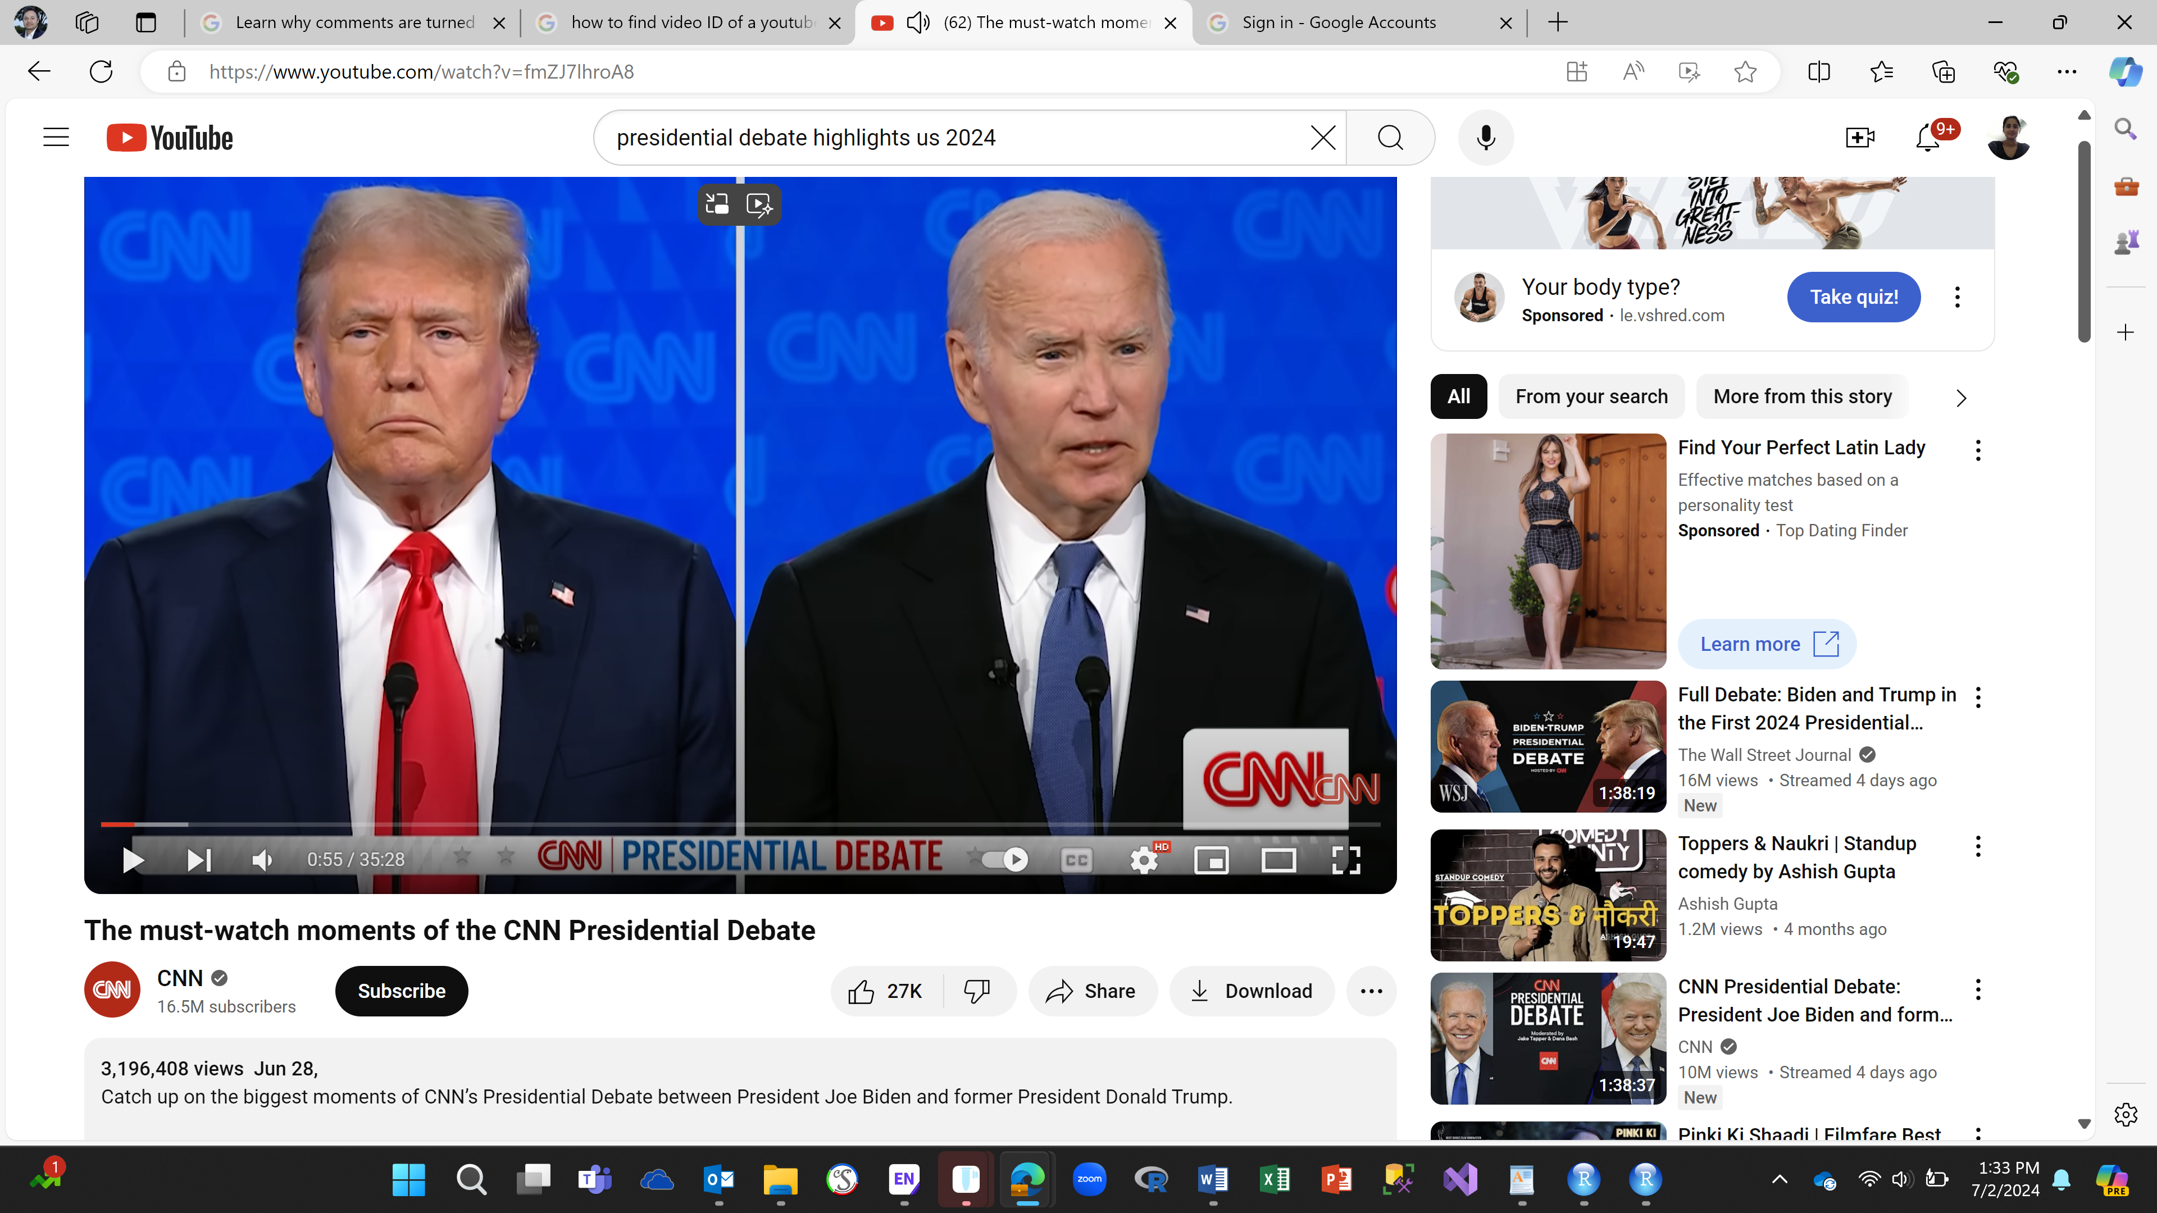

First, the analysis was performed to get general information about the video to count the number of views, likes, favorite, and comments. There were 3201,573 views, 27,625 likes, zero favorites, and 23,886 comments.

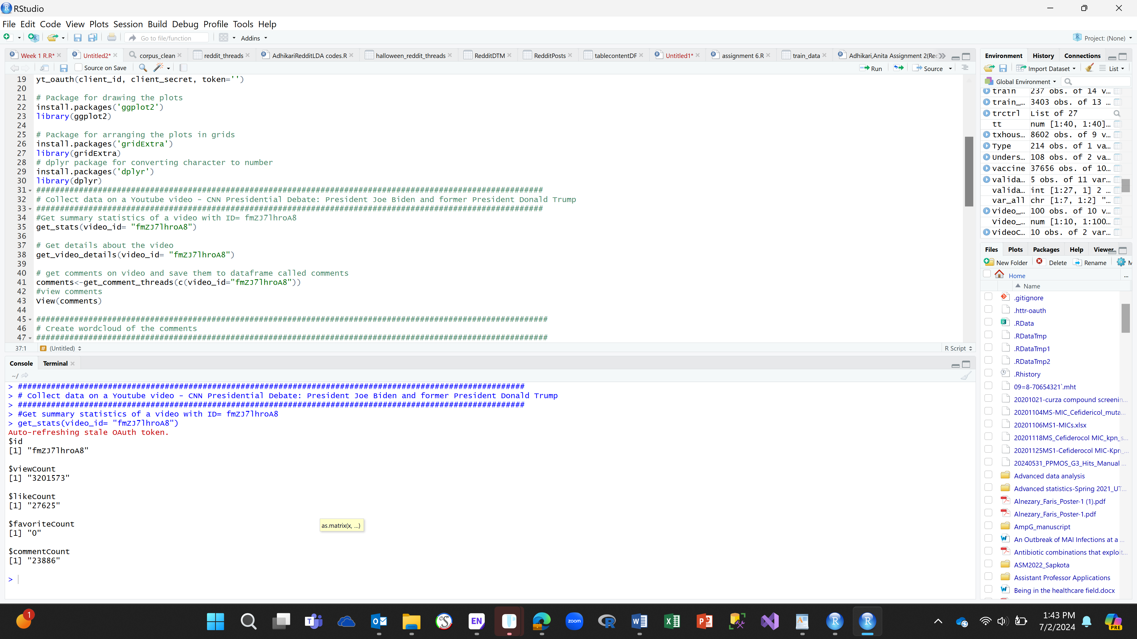

Next, I collected all comments on the video and saved them to a dataframe called comments.

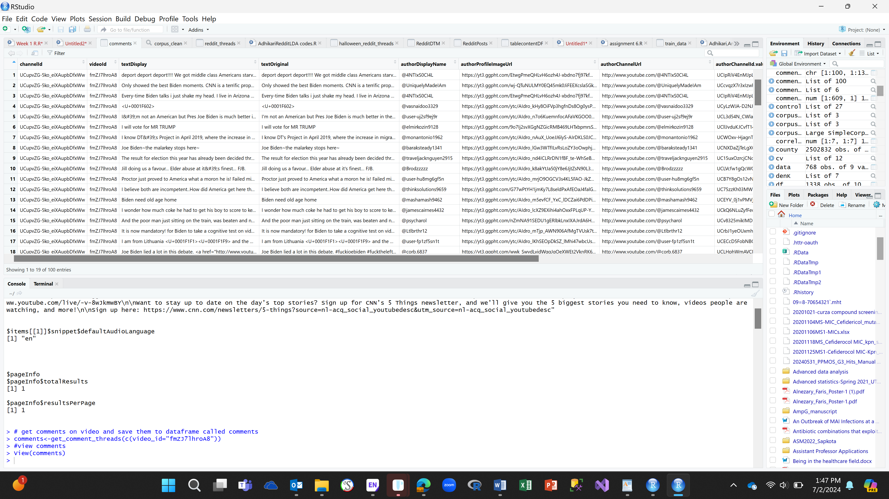

Then, the texts were processed to create a document- term-matrix (DTM). Here is the display of first 5 terms in DTM. As we can see terms ‘americans’, ‘class’, ‘deport’, ‘got’, and ‘middle’ were the 5 terms. We can get the frequency of the terms used in comments for example the word ‘class’ was used once in document 1 and document 27.

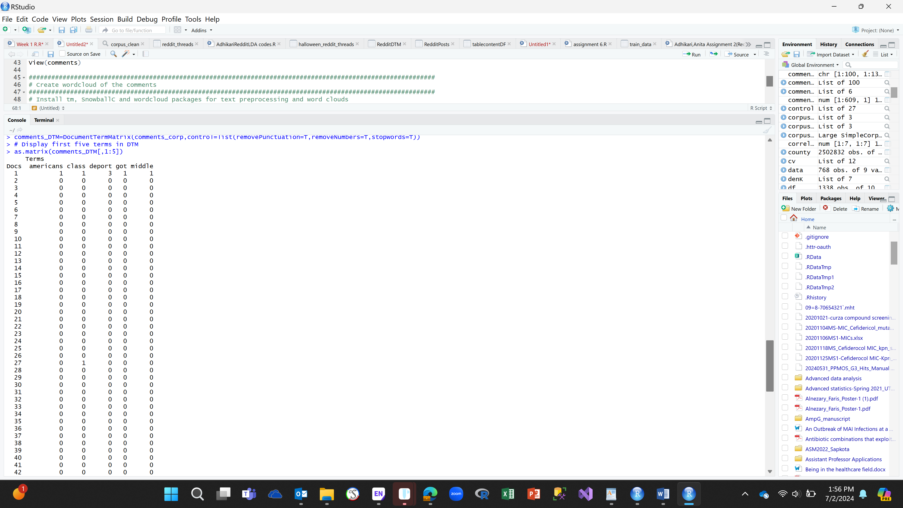

Here is a word cloud of comments. Words such as ‘man’, ‘followed’, ‘comedy’, ‘crazy’, ‘neighborhood’ were used in the comments as shown in the wordcloud below.

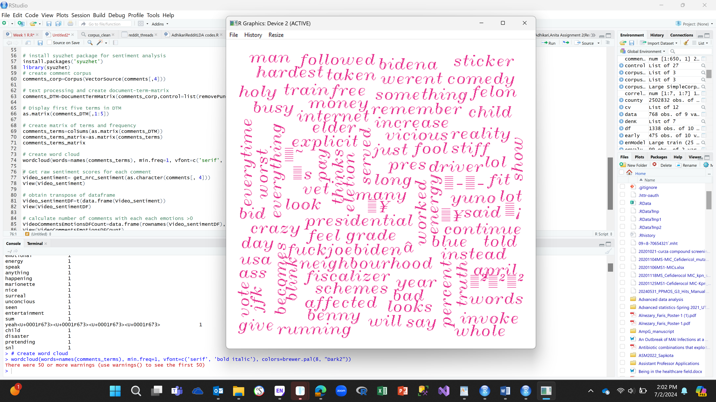

After that the sentiment scores of each comments were created. We can see that the first comment showed the emotions of fear and sadness with overall negative emotion whereas the fifth comment had emotions of anticipation, joy, surprise, and trust with overall positive emotion.

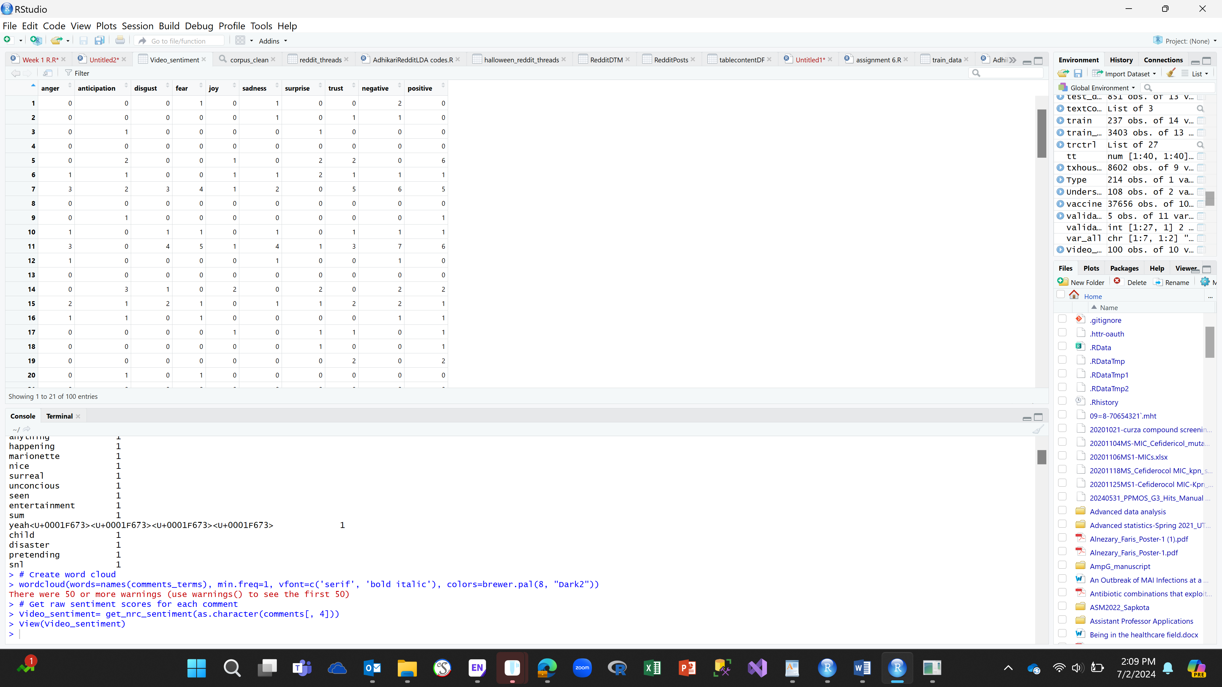

Furthermore, the frequencies of comments with each emotions were counted. As we can see in the table below, there were 33 comments that represented anger, 29 comments with anticipation, 32 with joy, 36 with trust 45 negative, and 45 positive emotions.

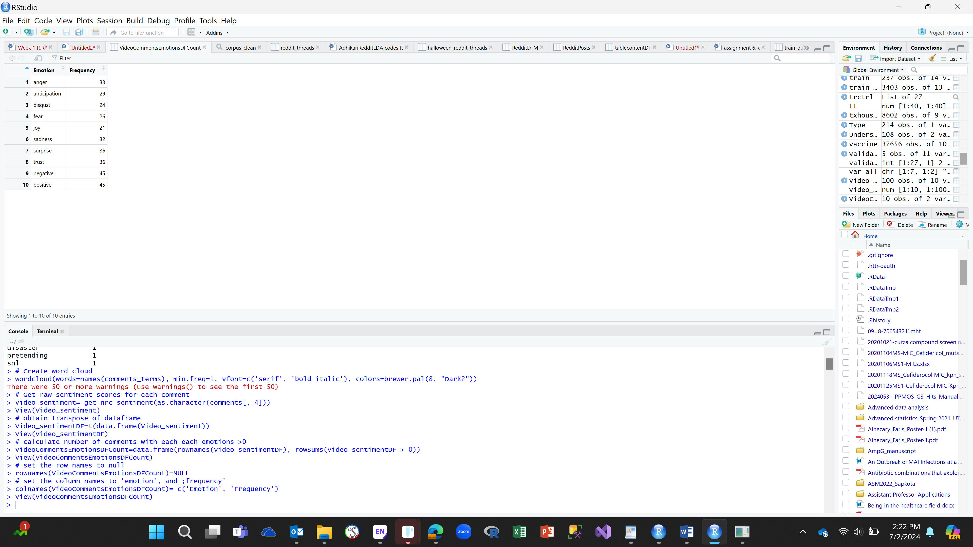

A bar diagram was plotted using the comments sentiment as shown below.

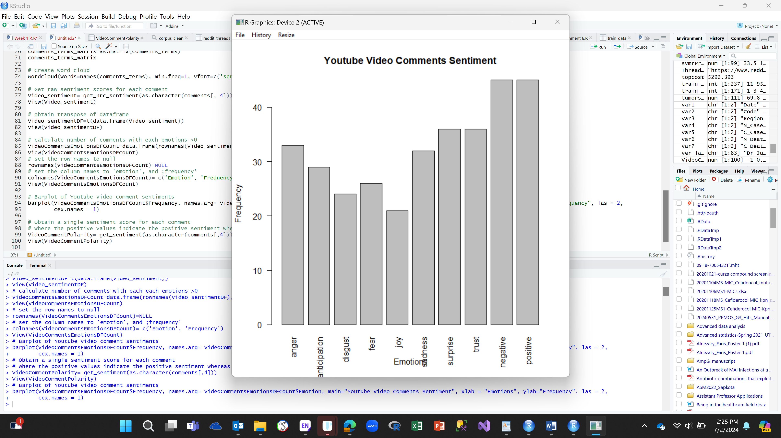

After that, a single sentiment score for each comment was obtained where the positive values indicated the positive sentiment whereas negative values indicated negative sentiment. When analyzing the 21 comments as shown below 12 of them showed negative emotions whereas 5 comments showed positive emotions.

